**Title: Constructing computational models simulating burn wound healing.**

## Background:

Perfect skin regeneration of burn wounds remains a challenge. There is still a lack of fundamental understanding of the interactions between different cell types, complex cell signalling networks and mechanical feedback loops during the wound healing process. Previous efforts have focused on constructing dynamic computational frameworks simulating cutaneous wound healing [1,2,3], but have not focused on burn wound healing.

In addition, dynamic computational models have been used to study the inflammation process in wound healing. Presbitero et al. [4] constructed a validated numerical systemic inflammation model under clinical treatment conditions of the Alkaline Phosphatase enzyme. Alkaline phosphatase (AP) exhibits anti-inflammatory effects by dephosphorylating inflammation triggering moieties (ITMs) like bacterial lipopolysaccharides and extracellular nucleotides.

These models are all not burn wound specific, therefore adjustments or an expansion of these models are demanded, to simulate the burn wound procedure. The link between the AP model and the cutaneous wound healing models, has not been investigated/found yet. By first performing a literature review focused on possible connections, this will be investigated. Constructing a computational model simulating burn wound healing would be a step forward towards a better understanding of dynamical adaptation to heal burn wounds.

**Research Question:**

What are the main factors influencing the burn wound healing procedure and how well can this procedure be modelled?

**Subquestions:**

What causes a better healing of burn wounds?

What is the link between the AP model and the cutaneous wound healing model?

## Approach

A mechanistic computational model based on literature knowledge will be constructed, which will eventually be clinically validated. To accomplish this, a number of experimental burn models will be studied on cellular behaviour/pathways affected by burns. We aim to design an Agent-based model combining the AP with the adjusted cutaneous wound healing model (adjusted in a way to fit the burn wound healing procedure). All previous efforts were programmed in Python, so using the python language, combined models will be built. Agent-based modelling is an object-oriented, rule-based, and discrete event computational modelling technique well suited for modelling cellular behaviour.

## Objectives

We hope to deliver a novel computational framework to simulate the healing of burn wounds. The model will bring together the found knowledge on continuum mechanics, growth and remodeling of cells. The model will be validated against clinical data from patient. Clinical trials will be performed with in cooperation with the ‘brandwondenstichting’. With this we hope to gain new insights in the influences of the different mechanics involved with burn wound healing.

**Difference with normal Wound Healing (mostly bold text)**

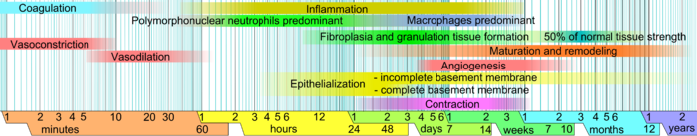

**Hemostasis:** Hemostasis and coagulation occurs through the formation

of a **blood clot of platelets and cross-linked fibrin and fibronectin** to quickly prevent

excessive fluid loss from the wound site. Injured vasculature rapidly constricts to stem

blood flow from the open vessels and later vasodilate to facilitate the entrance of blood cells to

the wound site needed in the inflammatory phase [9]. Whilst burn wounds **exhibit less blood**

**loss** than incisional wounds **due to heat-induced tissue coagulation**, there is **still significant**

**damage to the vasculature, with vasoconstriction extending out from the initial injury zone**

**and into the zone of stasis** [17]. Moreover, these early stages following burn injury may be

complicated by continued damage **due to the process of necrosis leading to a significant delay**

**in healing** [3, 4]. In all wounds though, key immune cells are recruited to the wound site by

signals released from degranulating platelets within the injured tissue

**Inflammation**:

In this regard, inflammation, which involves a variety of immune cells and mediators, plays a major role in the complex process of wound repair

This is same in all traumatic wounds. Immediately after the injury, inflammatory response of body begins which has vascular and cellular components.[[7](https://www.ncbi.nlm.nih.gov/pmc/articles/PMC3495387/#ref7)–[9](https://www.ncbi.nlm.nih.gov/pmc/articles/PMC3495387/#ref9)]

* Vascular response: Immediately after burns there is a local vasodilatation with extravasation of fluid in the third space. In extensive burn injury increased capillary permeability may be generalized leading to massive extravasation of plasma requiring fluid replacement.
* Cellular response: Neutrophils and monocytes are the first cells to migrate at the site of inflammation. Later on neutrophils start declining and are replaced by macrophages. The migration of these cells is initiated by chemotactic factors like kallkireins and fibrin peptides released from coagulation process and substances released from the mast cells like tumour necrosis factor, histamine, proteases, leukotreins and cytokines. Cellular response helps in phagocytosis and cleaning of dead tissue and toxins released by the burned tissue.

Within hours, the early inflammatory stage begins with the influx of immune cells to the wound site. Activated platelets aggregating at the ends of damaged vessels also release growth factors, such as platelet-derived growth factor (PDGF) and transforming growth factor-beta 1 (TGF-β1), to initiate fibroblasts and mesenchymal cells migration from surrounding the wound tissue which will be required for the formation of new extracellular matrix and dermal tissue during the proliferative phase of wound healing

<http://www.patfyz.sk/ZapalWEB/node8.html>

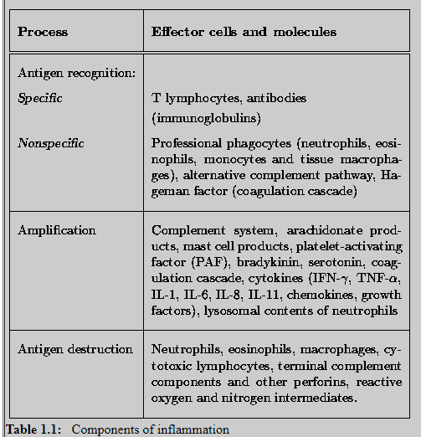

**Proliferation:** In partial thickness burns re-epithelialization starts in the form of keratinocyte migration from viable skin appendages in dermis few hours after injury, this usually covers the wound within 5-7 days. After re-epithelialization the basement membrane zone forms between dermis and epidermis. Angiogenesis and fibrogenesis help in dermal reconstitution.

Healing after burn excision and grafting: In deep burns after primary excision and grafting healing is by delayed primary intention. Take of skin graft after primary excision is the part of proliferative phase of wound healing.

During the proliferative phase of healing, cells of the epidermis and dermis, the keratinocytes

and fibroblasts, proliferate and migrate into the wound site to form the neo-epidermis,

restoring barrier function and produce new extracellular matrix which will reconstitute the

damaged dermis following injury [19, 20]. **The fibroblasts migrate along the fibrin-fibronectin**

**plug into the wound site where they synthesise collagen and elastin and begin remaking the**

**extracellular matrix (ECM)** [19]. Whilst fibroblasts migrate into the wound site and form granulation tissue and the new dermal layer, keratinocytes crawl across the provisional matrix for re-epithelialization of the wound to occur [20]. Also during this time, angiogenesis, stimulated by factors released during the inflammatory phase, sees the formation of new blood

vessels within the healing tissue [14]. This phase proceeds quickly to heal vertical injuries

such as those arising from an incision, or superficial burns which affect only the epidermis,

due to the availability of new epidermal cells from residual intact skin appendages residing

within the undamaged dermis [4]. However, deep dermal burns heal much slower because of

the loss of these skin appendages and reepithelialisation, which can only occur from the edges

of the wound, does not begin until the progression of necrosis is halted [21]. Endothelial cells

which form new capillary sprouts also interact with the ECM within the wound site, initially

producing a dense microvascular network and later, as the levels of collagen increase, reduce

the number of blood vessels leaving the resultant tissue with vascularisation levels similar to

that of the original tissue [22, 23].

**Remodeling:** Remodelling phase is the third phase of healing wherein the maturation of graft or scar takes place. In this final phase of wound healing initially there is laying down of fibrous structural proteins i.e., collagen and elastin around epithelial, endothelial and smooth muscle as extracellular matrix. Later on in the resolution phase this extracellular matrix remodels into scar tissue and fibroblast become myofibroblast phenotype which is responsible for scar contraction.

In second-degree deep dermal and full thickness burns which are left to heal of their own this resolution phase is prolonged and may take years and is responsible for hypertrophic scarring and contractures [[Figure 2](https://www.ncbi.nlm.nih.gov/pmc/articles/PMC3495387/figure/F2/)]. **Hyperpigmentation seen in superficial burns is due to overactive response of melanocytes to burn trauma and hypopigmentation seen in deep burns is due to destruction of melanocytes of the skin appendages**. In skin-grafted areas once inervation starts, the growing nerves alter the melanocyte control which usually leads to hyperpigmentation of graft in dark skinned and hypopigmentation of graft in white-skinned individuals.

What differences in this pathway of normal wound healing?

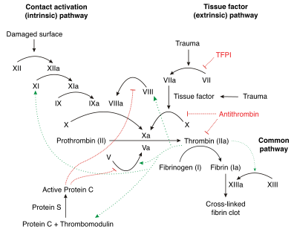

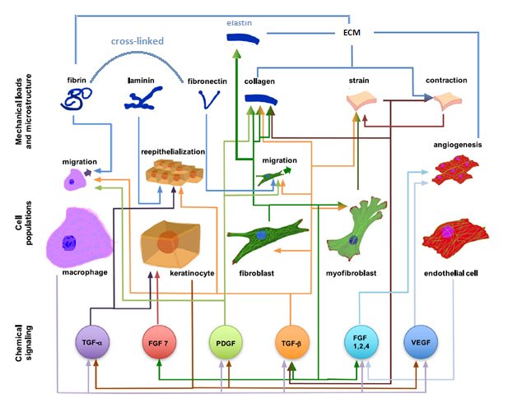Hemostasis: Thrombocytes (platelets missing) + cross-link fibrin and fibronectin

Whilst fibroblasts migrate into the wound site and form **granulation tissue** ( a tissue with a lot of blood vessels) **and the new dermal layer**,

However, deep dermal burns heal much slower because of the loss of these skin appendages and reepithelialisation, which can only occur from the edges of the wound, does not begin until the progression of necrosis is halted

* Burn injury induces a rapid systemic cytokine and chemokine responses, which differs from hat of excision injury
* Burn injury induces changes in systemic monocyte and neutrophil levels that are significantly different to those induced by excision
* Changes in dendritic cell population and maturation are different following burn and excision injury
* CD4 and CD8 T–cell activation and Treg cell responses differ between burn and excision injury
* Long-term alterations in immune profiles following burn and excision injury
* Burn injury leads to suppressed acute splenic T-cell cytokine responses

These conditions increase the patient’s susceptibility to infection leading to sepsis, systemic inflammatory response syndrome (SIRS), and multiple organ failure

### Model Spatio-temporal Wound Domain (Geometrical Considerations):

In general, the underlying chemo-bio-mechanical problem can be characterized

through three spatially and temporally interacting building blocks: chemical fields including substances such as growth factors and inflammation signals, biological fields including cell populations; and mechanical fields including the deformation, which can be locally supplemented by microstructural internal variables such as microstructural directions or microstructural concentrations

Like these guys: ‘

Computational modeling of chemo-bio-mechanical

coupling: a systems-biology approach toward

wound healing’

In order to examine the role that the wound shape or surface extent plays in the healing process, a 3d model will be constructed.

3 zones:

* Coagulation: This is the central part of burns with complete coagulative necrosis.
* Stasis: Zone of stasis is at the periphery of zone of coagulation. The circulation is sluggish in this zone but it can recover after early and adequate resuscitation, and proper wound care.
* Hyperemia: This is peripheral to zone of stasis. It is the result of intense vasodilatation as is seen in inflammatory phase after the trauma. This eventually recovers completely.

An external file that holds a picture, illustration, etc.
Object name is fig-3.jpg

Geometrical parameters:

* Length, width, Depth of burn (2nd – 0.12 to 2.0 mm), surface, volume
* Total Body surface area of burn (TBSA) (Wallace Rule of Nines)
* Burn Location/s

# Type of burns:

Thermal/Electrical/Scald

First-degree burn or epithelial burns - Skin is erythematic without vesication.

Second-degree burns - Involving epidermis and variable thickness of dermis. This is again divided into

* Second-degree superficial –where vesication and inflammation is seen in skin as only papillary dermis is involved.
* Second-degree deep -eschar formation is seen as it involves deep reticular dermis.

Third-degree burn - Also known as full thickness burns - eschar formation is present in these burns.

### Modeling Framework:

Dynamic model microenvironmental ABM model based on ‘Computational systems mechanobiology of wound healing’ paper

* **Discrete model**: the state variables change only at a countable number of points in time. These points in time are the ones at which the event occurs/change in state.
* **Continuous model**: the state variables change in a continuous way, and not abruptly from one state to another (infinite number of states).

ABM usually discrete models, right?

Discrete: the state variables change only at a countable number of points in time. These points in time are the ones at which the event occurs/change in state.

### Species to be included:

Oxygen

inflammatory cells

VEGF

TGF-β

Fibroblasts

ECM

Fluid requirement

**See figure previously mentioned**

### Development of Model Equations:

??

### Estimation of Model Parameter Values:

# Possible bio markers

<https://www.omicsonline.org/open-access/assessment-of-major-burn-patients-with-biochemical-markers-2168-9547-1000226-106486.html>

It was discovered that the burn disease was accompanied by deeply marked secondary immune deficiency primarily caused by all components of the active suppression of the cellular link of the immune system and reduction of phagocyte activity of neutrophils.nothing on git yet

The expression of pro- and anti-inflammatory cytokines is significantly altered following burn injury,8 and the concentration of these cytokines alone or with respect to each other (the expression profile)

**TNF-α** is mainly secreted by activated macrophages immediately postburn. The host immune response is activated by TNF-α, as is the subsequent release of cytokines following trauma and infection. TNF-α also plays a role in angiogenesis and wound healing. Several studies have identified TNF-α as a predictive marker for the development of septic complications in burn patients.

**Interleukin 10 (IL-10),** also known as human cytokine synthesis inhibitory factor (CSIF), is an anti-inflammatory cytokine.

**IL-8** (or CXCL8) is a chemokine that is released early postinjury mainly by macrophages. IL-8 is an important protein related to inflammation, where it plays a key role in the recruitment of neutrophils and other immune cells to the site of infection.

**IL-6** is released by T cells and activated macrophages during the acute-phase response following injury or trauma and may lead to inflammation or infection. IL-6 has both proand antiinflammatory properties. In burns, IL-6 concentrations are significantly increased when compared to IL-6 levels in nonburn volunteers.

**C-reactive protein (CRP)** is a commonly used marker of an acute inflammatory response and is a serum amyloid P component belonging to the pentraxin family of calcium-dependent ligand-binding proteins; it serves as a marker of inflammation. Synthesis of CRP occurs in the liver and is triggered by the release of IL-6 in response to tissue damage or infectious stimuli. Elevation of CRP expression occurs several hours after the onset of the increase in IL-6. **NOT in AP model.**

**Leptin** is a circulating hormone primarily secreted by adipose tissue and involved in the regulation of feeding and energy homeostasis through central nervous system afferent pathways.40 Leptin also plays a role in angiogenesis41 and stimulates T cells and monocytes to induce cytokine release. **NOT in AP model.**

TGFa

Collagen formation, indicated by the hydroxyproline content of the sponge, was significantly lower in the group treated with TNF-alpha than in the controls

Patients with infected **SIRS** differ significantly from **non-infected SIRS** in **PCT** (procalcitonin levels can be used as an early indicator of septic complication in patients with severe burn injury). recent reports demonstrated that PCT plasma concentrations in septic patients are correlated to organ failure. CRP induction is mediated by interleukin-6 (IL-6) and either IL-1 or tumor necrosis factor-a (TNF-a). Therefore, CRP synthesis and secretion usually reflects proinflummatory cytokine production and may be considered as surrogate marker

Macrophages

An external file that holds a picture, illustration, etc.
Object name is nihms-1024099-f0002.jpg

### Relevant Socio-markers

* Age
* Gender
* Unnecessary but possible:
* Stress hormones alter biological mechanisms including inflammatory and immune responses.

It is clear that prolonged and/or excessive inflammation in the early stages of

burn injury leads to excessive fibrosis and scarring [63]. In particular, the numbers of macrophages

found within a wound at specific times of the healing cascade are associated with

the level of fibrosis and scar formation observed [10]. Anti-inflammatory cytokines have also been examined for their antiscarring effects.

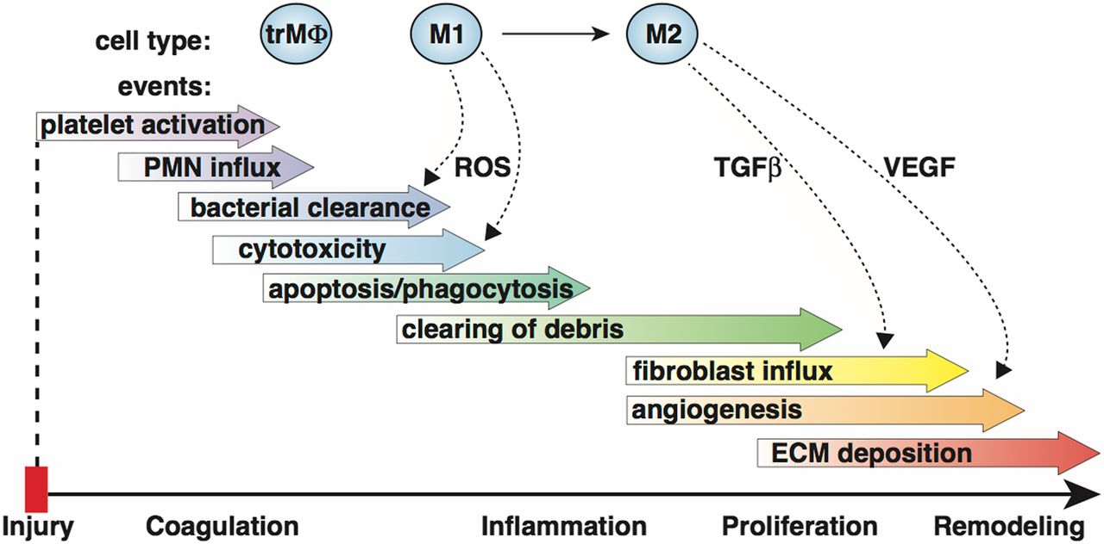

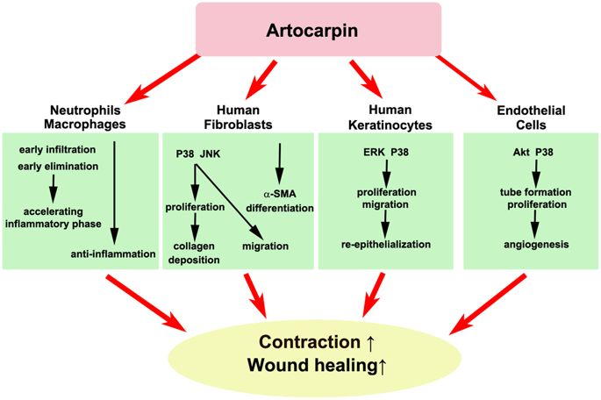

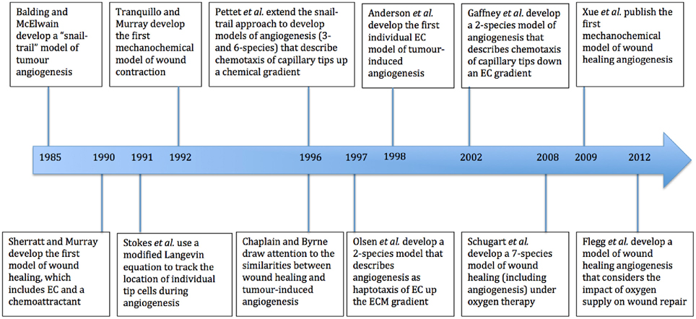

**References:**

1. Buganza Tepole, A. (2017). Computational systems mechanobiology of wound healing. *Computer Methods in Applied Mechanics and Engineering*. <https://doi.org/10.1016/j.cma.2016.04.034>
2. Flegg, J. A., Menon, S. N., Maini, P. K., & McElwain, D. L. S. (2015). On the mathematical modeling of wound healing angiogenesis in skin as a reaction-transport process. *Frontiers in Physiology*. https://doi.org/10.3389/fphys.2015.00262
3. Ziraldo, C., Mi, Q., An, G., & Vodovotz, Y. (2013). Computational Modeling of Inflammation and Wound Healing. *Advances in Wound Care*. <https://doi.org/10.1089/wound.2012.0416>
4. Presbitero, A., Mancini, E., Brands, R., Krzhizhanovskaya, V. V., & Sloot, P. M. A. (2018). Supplemented alkaline phosphatase supports the immune response in patients undergoing cardiac surgery: Clinical and computational evidence. *Frontiers in Immunology*. https://doi.org/10.3389/fimmu.2018.02342